AP Biology Summer Review Sheet

The purpose of this worksheet is to re-familiarize yourself with material from your introductory course in Biology. The AP Biology curriculum is designed based the assumption that you remember this material, as well as material from your introductory Chemistry class.

Using your old notes or a textbook, please work through the review sheet. This worksheet will not be graded, but I will collect it to see that it was completed and to see what areas require review. Please do not discount this assignment because it is not graded. Much of the work in AP Biology will involve reading, studying, and reviewing independently; in other words, tasks that are not graded. However, these are tasks that will determine your success in the course. Again, re-familiarizing yourself with this material will help immensely as we go through the more advanced content of AP Biology.

Please turn in the review sheet on paper or by email.

I. Biochemistry

1. Fill in the chart below summarizing the four macromolecules.

Macromolecule | Subunits  (monomers) | Function | Contains which of the following:  C, H, O, N, P | Examples
Carbohydrates

Lipids

Proteins

Nucleic Acids

2. Sketch the molecules ADP and ATP. Explain their relationship and function.

3. Draw the chemical structure of a water molecule, indicating its polarity.

II – Cellular Biology

- List the function and describe the structure of the following cellular structures.

a. nucleus –

b. plasma membrane –

c. cell wall –

d. mitochondria –

e. chloroplast –

f. ribosome –

g. endoplasmic reticulum –

h. Golgi apparatus –

- Compare and contrast eukaryotic cells and prokaryotic cells.

- Compare and contrast plant cells and animal cells.

- What is homeostasis?

- Define:

a. semi-permeable membrane –

b. diffusion –

c. osmosis –

d. passive transport –

e. active transport –

- Explain how an enzyme functions, including the terms substrate and active site.

7. Label the following pictures of cells with the correct phase of mitosis.
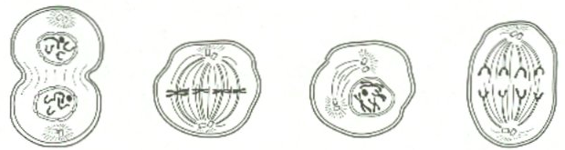

III – Cellular Respiration and Photosynthesis

1. Write the chemical reaction for cellular respiration (aerobic respiration).

2. Name the three stages of cellular respiration and briefly describe what happens
in each stage. In which step is most ATP produced?

3. Define fermentation (anaerobic respiration).

4. Write the chemical formula for photosynthesis.

5. Name the two stages of photosynthesis and briefly describe what happens in
each stage.

6. Cellular respiration occurs in (plants / animals / both)?

7. Photosynthesis occurs in (plants / animals / both)?

IV – Molecular Biology

1. Name the nitrogenous bases found in DNA and RNA. State which bases bind to
each other according to Chargaff’s rules.

2. Why is the sequence of nucleotides in DNA so important?

3. Briefly describe the process of DNA replication.

4. Briefly describe the process of transcription.

5. Briefly describe the process of translation.

4. What is a mutation? How could a mutation alter a protein?

5. What is meant by the term gene expression?

6. What is meant by the term cell differentiation?

V – Genetics

1. Compare and contrast mitosis and meiosis in terms of DNA replication, number of
divisions, and number and characteristics of chromosomes in daughter cells.

2. Define:
a. diploid –

b. haploid –

3. Define:

a. dominant –

b. recessive –

c. homozygous –

d. heterozygous –

e. genotype –

f. phenotype –

4. Complete the following genetics problems using Punnett squares.

a. Two heterozygous tall plants are crossed. If tall is dominant over short, what
are the expected phenotypic results?

b. If one homozygous short plant is crossed with a heterozygous tall plant, what
percentage of the offspring will be short?

c. What are the potential genotypes of the parents that would produce 25% short
and 75% tall pea plants?

5. When red flowers and white flowers are crossed, pink flowers are produced. Using a
Punnett square, what ratio of flower color is expected when two pink flowers are
crossed? (Hint: this plant exhibits incomplete dominance.)

6. Using a Punnett square, determine the blood types of the children when their father
is heterozygous for type B and their mother is heterozygous for type A.

7. Colorblindness is a sex-linked recessive trait. A colorblind woman and a man with
normal sight have children. Using a Punnett square determine the eyesight of their
children.

8. Answer the following questions using the pedigree chart below.
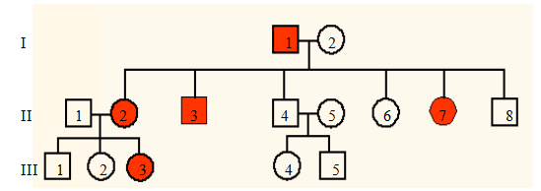

a. What does a shaded square represent? An non-shaded circle?

b. What is the genotype of individual I-1?

c. What is the genotype of II-4?

d. Is the trait shown dominant or recessive? Sex-linked or autosomal?

VI – Biotechnology

1. Define the following:

a. transgenic organism –

b. cloning –

c. gel electrophoresis –

d. bacterial transformation –

VII – Evolution

1. Explain evolution using Darwin’s theory of natural selection.

2. List several pieces of evidence for evolution.

3. Describe the 3 domain, 6 kingdom classification system.

4. List the 7 levels of organism classification from largest to smallest. (Do you know an
acronym to remember this?)

5. Indicate if each of the following organisms is a prokaryote or eukaryote, autotroph or
heterotroph, and unicellular or multicellular. Note: some organisms may have both
characteristics.

Bacteria – pro / euk auto / hetero uni / multi
Protists – pro / euk auto / hetero uni / multi
Fungi – pro / euk auto / hetero uni / multi
Plants – pro / euk auto / hetero uni / multi
Animals – pro / euk auto / hetero uni / multi

VIII – Animal Kingdom

1. State the basic characteristics for each organism and give two examples of each.

a. annelids worms –

b. arthropods –

c. insects –

d. fish –

e. amphibians –

f. reptiles –

g. birds –

h. mammals –

i. primates –

2. Distinguish between sexual and asexual reproduction.

IX – Plants

1. Which cells allow water transport in plants? Sugar transport?

2. Define:

a. phototropism –

b. transpiration –

c. stomata –

X – Anatomy & Physiology

1. Describe the basic functions of the following body systems:

a. integumentary –

b. cardiovascular –

c. respiratory –

d. digestive –

e. excretory –

f. skeletal –

g. muscular –

h. nervous –

i. endocrine –

j. immune –

k. reproductive –

XI - Ecology

1. Define the following and give an example:

a. biotic –

b. abiotic –

2. What is a food web?

3. What is a trophic level?

4. How does energy move through an ecosystem?

XII – Laboratory

1. An experiment was performed to determine how much fertilizer was needed to
produce the most pumpkins. The results are shown below.
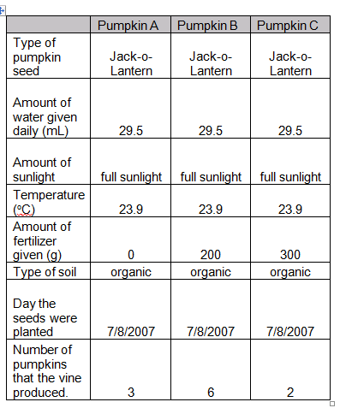

a. What is the question being asked in this experiment?

b. What is the independent variable?

c. What is the dependent variable?

d. What are the constants?

e. What is the control? Why is it needed?

f. How much fertilizer should you use to grow the most pumpkins?

